**Name: Anupam Kumar Jha | Roll No.: 21f1004905**

**BDM PROJECT**

**To Increase the Sale and Reduce the Manufacturing Cost of a Firm of Bricks Industry**

* **Executive Summary:** This project has been created to address some of the problems of Ramdev Bricks Manufacturers located in Amet, Rajsamand(Rajasthan). It’s a brick-manufacturing company. The company is facing issues in sales as the potential of the bricks industry is increasing in this area but their sales are not increasing as much resulting in lesser profit than this firm can generate. The intended data has shown that the cost of making bricks is also higher which effectively decreases the net profit of the firm. So, this project has been designed to solve the problem of sales of bricks and reduce the cost of manufacturing, ultimately increasing the net profit. To solve the problem a predefined process/methods will be used whose description has been given in the document. The intended data will be collected with the help of stakeholders. And data will be analyzed with some industry standard tools. And to solve the problem, data is going to be analyzed and after talking with some of the industrial experts and doing some research, the problem will be addressed which may increase the net profit of the company. The expected deadlines for the project have been given in the document.
* **Organization Background: Ramdev Bricks Manufacturer** is a firm located in **Amet, Rajsamand(Rajasthan)**. The firm was situated around 1992. The firm manufactures bricks. It is one of the well-known firms in the brick industry in the area of 50 Km. radius around the location. The annual sale of the company is around 10,00,000 bricks. They sell three qualities of bricks. The price of the brick type varies according to the quality. The quality of bricks depends on the raw material and the process of manufacturing. Around 7-8 workers work here. The business was established by **Mr. Boli Ram Prajapat** & **Mrs. Rukma Devi** and now it’s run by their son **Mr**. **Rahul Prajapat**. Mr. Rahul Prajapat: 7891414306

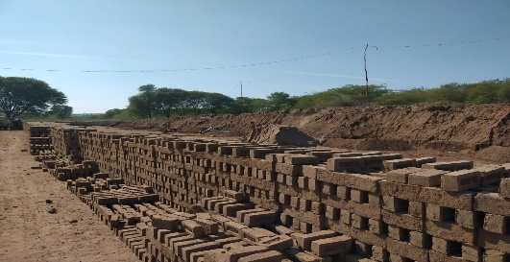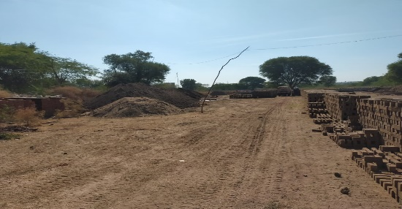

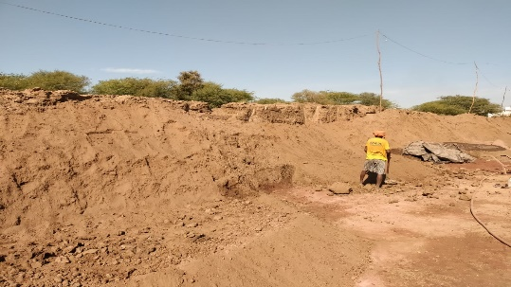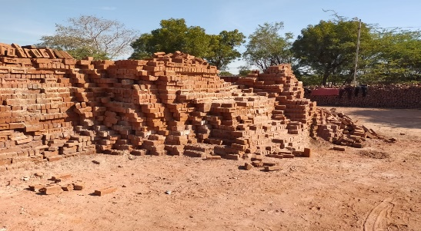

* **Problem Statement:**
  1. Increase the sale of Ramdev Bricks Manufacturers.
  2. Reduce the Manufacturing Cost.
* **Problem Background:**
  1. After talking to stakeholders one of the biggest problems they are facing is the problem of sales. The demand for bricks is increasing in the area as there is lots of construction work going on in the area but they are unable to catch that demand because of various reasons. On average in a radius of 50 Km. around 1000 houses are constructed. And on average to construct a house of 1800 sq. feet around 30,000 bricks are needed. So the demand of the industry is 3,00,00,000 bricks annually and the current capacity of the firm is around 10,00,000 bricks on an annual basis which means they capture only 3.33 % percent of the market. If the market share could be increased it will lead to a growth in net profit.
  2. The manufacturing cost of the bricks is also higher. For example, right now it cost around ₹4/brick. But you can’t go beyond ₹5.5/ brick as the selling price because it’s been a competitive market so if the firm increases the price there is a chance of losing volume in the market. So if the firm could reduce their cost it will have two impacts. First, the margin will increase and they could sell the bricks at a lower price which will increase their volume in the market and ultimately increase their net profit.
* **Problem-Solving Approach:**
  + 1. **Methods/Process to be Used to Solve the Problem**:
    2. Talks with industry experts: To solve the problem we need to talk with industry experts that how the industry functions to go deep into the problem and give recommendations according to the problem.
    3. Analysis of Data: To solve the mentioned problem we are taking the help of data. So first data is needed to be analyzed to check whether the problem is occurring, and what is the frequency of the problem. Then we need to find what is the cause of the problem with the help of data.
    4. Finding Solution: After analyzing the data and finding the causes we can research what can be done to solve the issue with the help of industry people, referring to the internet and some books.
    5. Talks with Stakeholders: After finding the solutions we can present them to stakeholders and can explain to them the solution and its impact on their overall business.
    6. **Intended Data Collection:**

1. The sales and manufacturing data are needed to be collected to know the exact capacity of the firm to analyze the sales problem of the firm. This will be acquired with the help of the owners.
2. To know about market demand, we will be taking qualitative data and rough data from people who know this industry and the construction industry as the firm is dependent on the construction industry.
3. The details about fixed costs such as land assets, and transport assets will be collected.
4. The details about variable costs such as raw-material like water, coal, etc, and labour costs will be collected.
5. To find a solution some information would be gathered with the help of the internet such as the price of coal, transportation cost, etc.
   * 1. **Analysis Tools**: Throughout the project, MS Excel will be used as it’s standard tool in any industry. It’s some features to clean up data like find and replace. We can also get descriptive statistics about the data. To get deeper and present data compactly it has some amazing graphs to present data. It’s the feature to know about the trend in data etc.

* **Expected Timeline:**

This is the screenshot of expected timeline:

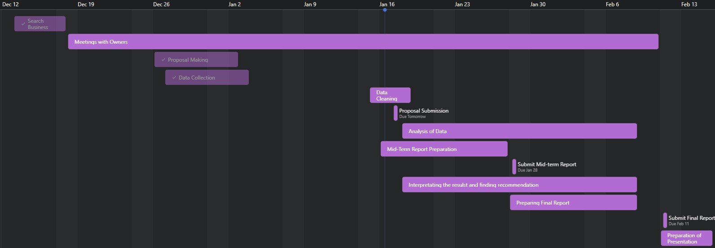

* **Expected Outcome:**
  1. After analyzing and giving recommendations to the firm, the firm can expect a growth in their sales that leads to growth in net profit.
  2. After applying the recommendation firm can expect a decrease in their manufacturing cost that ultimately leads to growth in sales and that will lead to growth in the net profit of the firm.